**SELENIUM LABS**

**Lab Demo 1: Example (Basic Selenium IDE Flow)**

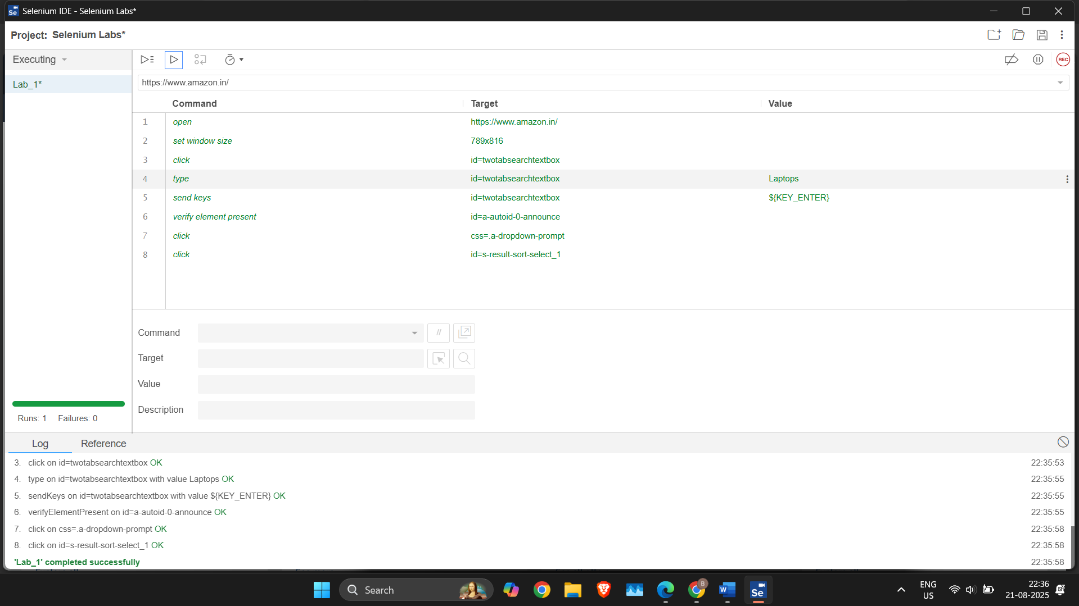

**Lab Demo 2: Learning Selenium IDE (Modifications)**

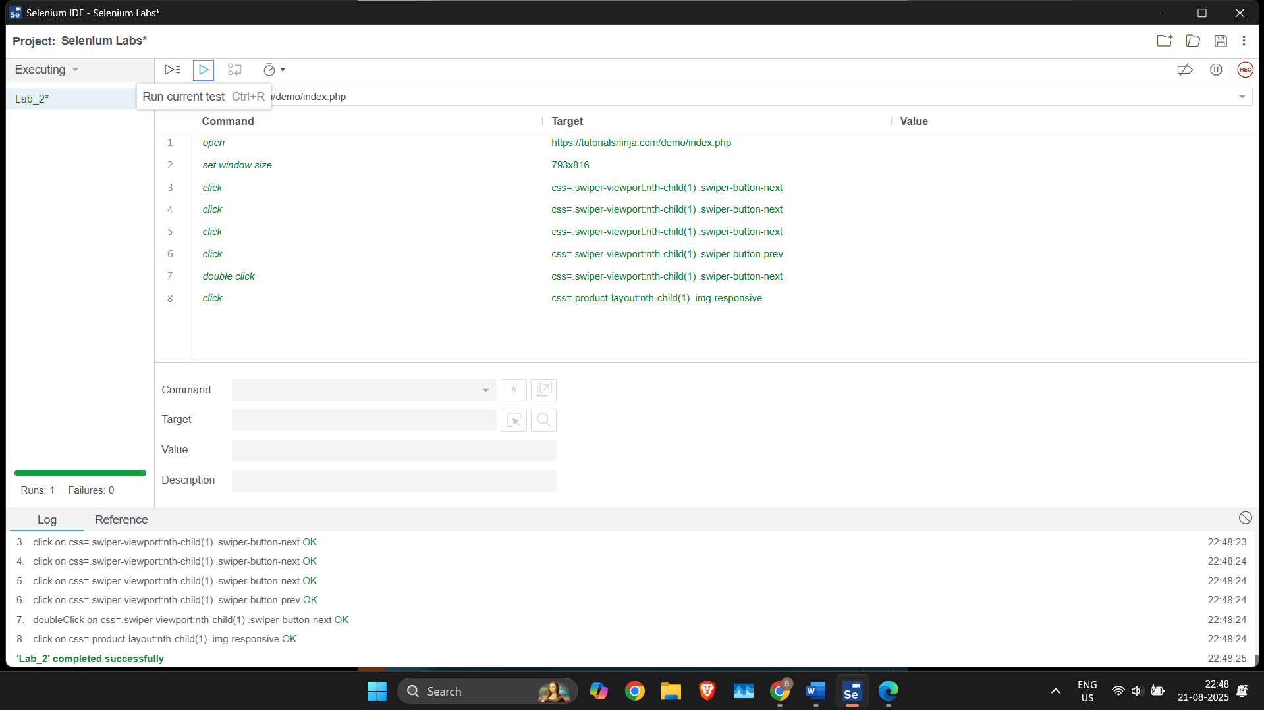

**Lab Demo 3: Learning Selenium IDE(Basic Flow)**

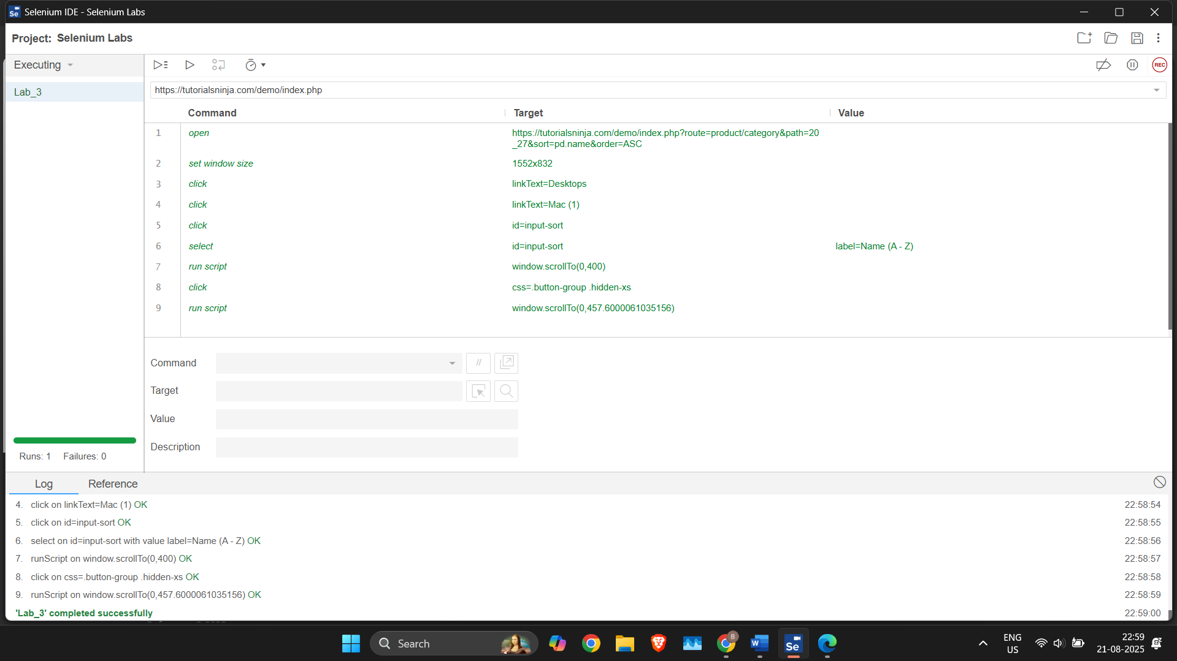

**Lab Demo 4: Learning Selenium IDE(Performing Validations)**

